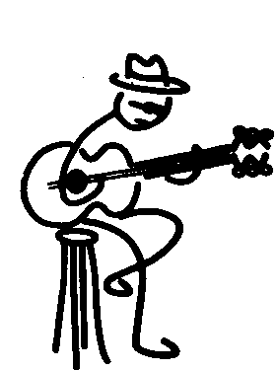
2018 Blues Society of Tulsa Event Sponsorship
Application

The Blues Society of Tulsa is a 501C organization dedicated to promoting local Tulsa blues musicians. Please complete below application and submit to: RybackiCC@yahoo.com or by postal to P.O. Box 2836, Tulsa, OK 74101. For questions call 918-520-2453.

Business Name: _____________________________ Contact Name: _____________________
Address: ______________________________________________________________________
Phone Number(s): ______________________________________________________________ Fax: ___________________________ E-mail: ________________________________________
CASHIERS CHECK/MONEY ORDER ENCLOSED: ___ / CREDIT CARD (VISA/MC): ___
Name as shown on card: _________________________________________________________
Credit Card #: __________________________________________________________________
Exp. Date (MO/YR): ______/______CV# (3 digit number on back of card): ____________
Billing Address & Zip Code: ______________________________________________________
______________________________________________________
Event Sponsorship (Choose):
Each selection will include promotion in all BST event related marketing (to include Blues Society Newsletter, Website, Social Media), event recognition, banner with your company name and logo displayed at event (please logo/layout).
□Blues Choice Awards/Blues Society Birthday Party - $350 This event held in March hosts winners of the Blues Choice Awards. (3’X5’ banner included)
□Summer Blues Showcase - $350 This event held in June showcases Tulsa area blues musicians. (3’X8’ banner included)
□Band Challenge Competition - $750 This event is held in August at Cain’s Ballroom. Winner of the Challenge will represent Northeast OK in the International Blues Competition in Memphis, TN. (3’X8’ banner included)
□Solo/Duo Challenge - $350 This event is held in September. Winner of the Challenge will represent Northeast OK in the International Blues Competition in Memphis, TN. (3’X5’ banner included)
□Blues Society Christmas Party - $350 This event is held in December with great live entertainment to celebrate the holiday season. (3’X5’ banner included)
□ In-Kind SPONSOR - Exchange of goods/services for promotional consideration. List below with value.

Additional Information:
________________________________________________________________________________________________________________________________________________________________________________________________________________________________________________
Tulsa Blues Society of Tulsa
3963 S. Hwy 97 •Ste. 177 • Sand Springs, OK • 74063-3829•877-349-2663
FEIN: 45-4628368

